

CSC 1300 LAB 4 PURPLE

**Spring 2023, February 13, 2023 through February 16, 2023**

# Concepts

* Relational expressions & logical operators
* While loop for input validation

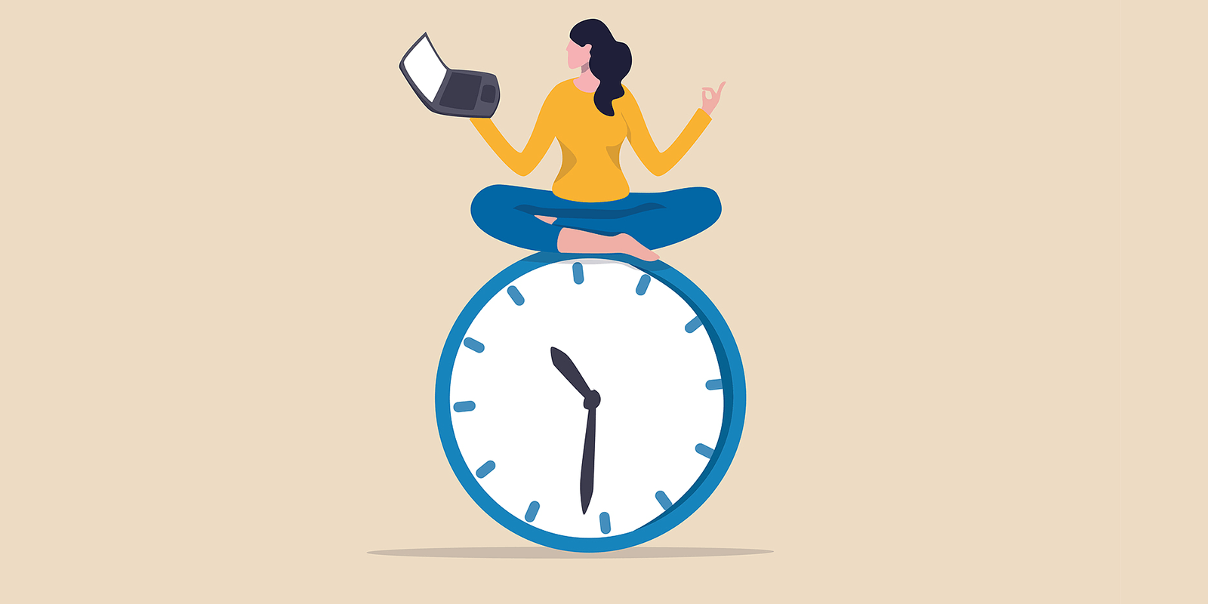

Photo Credit: <https://www.flexjobs.com/blog/post/science-based-time-management-hacks/>

## DIRECTIONS

* In your **CSC1300LAB** folder, create a **LAB4Purple_yourTTUusername** folder and inside that folder, create a source file named **lab4.cpp**.
* You will **ask the user** for their average daily screen time in hours as well as their average daily study (or homework) time they spend in hours.
* **Validate the user’s input** to make sure they enter a number 0 through 24. If they don’t then give them an error message and tell them to enter again and then read it in again. A flow chart representing the algorithm for this is below.

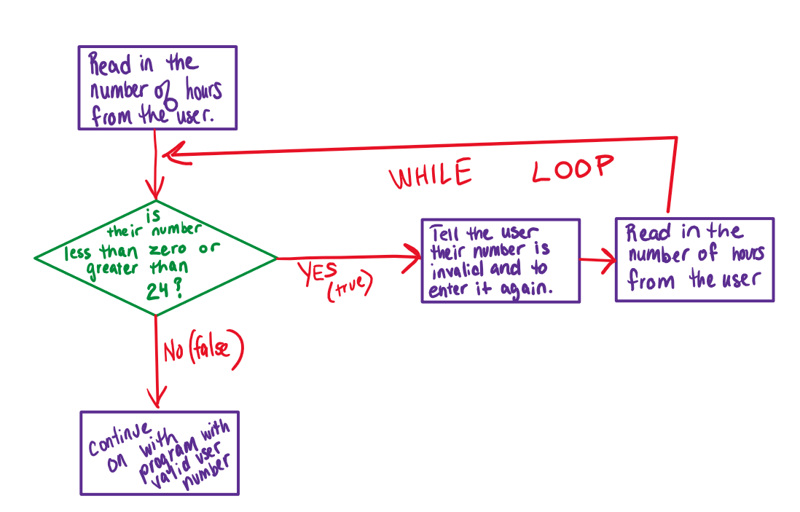

* Then, based on what they answer, you will print out advice on how they should spend their time.
* **You must use logical operators in your solution.**
* Below is the logic you should use to print your statements:
  + Screen time less than or equal to 2 and study time is less than 2 then print “You may want to study more if you wish to learn anything.”
  + Screen time less than or equal to 2 and study time greater than or equal to 6 then print “You need to socialize with people more often”
  + Screen time greater then 2 and study time greater than or equal to 6 then print “You need to socialize with people more often and get off that phone.”
  + Screen time less than or equal to 2 and study time greater than or equal to 2, but less than 6, then print “You manage your time well.”
  + Screen time greater than 2 and study time less than 6 then print “What are you going to do if you lose that phone? It is interfering with your ability to have a real life.”
* Make sure to test your code with all 4 sample outputs below to make sure your code logic is correct!

## sample output

### Sample Output 1

Rounding to the nearest hour, how many hours is you daily average PHONE screen time?

AVG DAILY SCREEN-TIME HOURS: **2**

Rounding to the nearest hour, how many hours is your daily average study or homework time?

AVG DAILY STUDY or HOMEWORK HOURS: **6**

You need to socialize with people more often.

### Sample Output 2 (checks your while loops)

Rounding to the nearest hour, how many hours is you daily average PHONE screen time?

AVG DAILY SCREEN-TIME HOURS: -8

OH BARF! That's an invalid number! Enter 0 through 24: 28

OH BARF! That's an invalid number! Enter 0 through 24: 1

Rounding to the nearest hour, how many hours is your daily average study or homework time?

AVG DAILY STUDY or HOMEWORK HOURS: 96

OH BARF! That's an invalid number! Enter 0 through 24: 3

You manage your time well.

### Sample Output 3

Rounding to the nearest hour, how many hours is you daily average PHONE screen time?

AVG DAILY SCREEN-TIME HOURS: **3**

Rounding to the nearest hour, how many hours is your daily average study or homework time?

AVG DAILY STUDY or HOMEWORK HOURS: **6**

You need to socialize with people more often and get off that phone.

### Sample Output 4

Rounding to the nearest hour, how many hours is you daily average PHONE screen time?

AVG DAILY SCREEN-TIME HOURS: 1

Rounding to the nearest hour, how many hours is your daily average study or homework time?

AVG DAILY STUDY or HOMEWORK HOURS: 1

You may want to study more if you wish to learn anything.

### Sample Output 5

Rounding to the nearest hour, how many hours is you daily average PHONE screen time?

AVG DAILY SCREEN-TIME HOURS: **5**

Rounding to the nearest hour, how many hours is your daily average study or homework time?

AVG DAILY STUDY or HOMEWORK HOURS: **1**

What are you going to do if you lose that phone?

It is interfering with your ability to have a real life.

## What to Turn In

**Compress/zip** the **Lab4Purple_yourTTUusername** folder and upload it to the ilearn assignment folder named **Lab 4**.